Darjeeling - Sikkim Tour

(28th October to 6th November 2005)

Itinerary

28th October 2005 (Bangalore – Kolkata)

- Departure to Kolkata by Air Deccan at 15:30
- Arrival at Kolkata airport (Dum Dum) at 18:00
- Dinner at Kolkata airport around 19:30
- Departure to New Jalpaiguri (NJG) at 22:05 from Sealdah (15 Km from Dum Dum) by Darjeeling Mail (3rd AC)

29th October 2005 (New Jalpaiguri – Darjeeling)

- Arrival at NJG at 08:40
- Departure to Darjeeling by Sumo/16 seater van at 09:30
- Check-in Viceroy Hotel (http://www.viceroyhoteldrj.com) at 13:00 for lunch. Viceroy Hotel is a 3star good-facility and centrally located hotel.
- After lunch: Sightseeing tour of Darjeeling includes
  - Zoo
  - Himalayan Mountaineering Institute
  - Everest Museum
  - Tea Garden
  - Rock Gardens
  - Gangamaya Lake
- Dinner and overnight stay in Viceroy
30th October 2005 (Darjeeling)

- After breakfast day excursion to Mirik and back
- Overnight stay at Viceroy hotel, Darjeeling

31st October 2005 (Darjeeling - Gangtok)

- Early morning 05:00 Sunrise tour to Tiger Hill
- Visit
  - Ghoom Monastery
  - Batasia Loop on the way back.
- After breakfast, drive to Gangtok (4 hrs drive to Gangtok).
- Check-in at Sonam Palgey (http://www.sonampalgey.com) - a luxury ethnic hotel.
- Overnight stay at Gangtok.
1st November 2005 (Gangtok)

- After breakfast: Sightseeing tour to
  - Rumtek Monastery
  - Orchid Nurseries
  - Museum
  - Enchey Monastery
  - Cottage Industry
  - Hanuman Tok
  - Zoo
- Overnight stay at Gangtok

2nd November 2005 (Gangtok)

- After breakfast: Himalayan Jeep Safari to
  - Tsomgo Lake
  - Nathula Pass (Indo-China border)
- Dinner at Sonam Palgey and overnight stay

3rd November 2005 (Gangtok – Pelling)

- After breakfast driver to Pelling (4 hrs)
- Overnight stay at Hotel Newa Regency (http://www.newaregency.com), Pelling

4th November 2005 (Pelling)

- After breakfast : sightseeing trip to
  - Rimbi Falls
  - Khasheodpelri sacred lake
  - Khangchendzonga Falls
  - Sangay Falls
  - Singshore bridge
  - Pemayangtse Monastery
  - Rabongla (if possible)
  - Temi Tea Estate (if possible)
  - Ralong monastery (if possible)
- Dinner & overnight stay at Newa Regency, Pelling

5th November 2005 (Pelling – New Jalpaiguri)

- After breakfast drive to New Jalpaiguri railway station (6 hrs)
- Departure to Kolkata at 16:20 hrs by NJSD special train.

6th November 2005 (Kolkata – Bangalore)

- Arrival at Sealdah (Kolkata) around 05:15
- Breakfast at Dum Dum airport
- Departure to Bangalore at 11:45 by Deccan Airways
- Arrival at Bangalore airport by 14:15

Distance Chart

SILIGURI, 329 FT

080 | DARJEELING, 7800 FT

065 | 052 | KALIMPOMNG, 4100 FT

097 | 084 | 032 | LAVA, 8000 FT.

114 | 094 | 075 | 110 | GANGTOK, 5800 FT

235 | 256 | 200 | 246 | 137 | YUMTHANG, 12210 FT

133 | 118 | 080 | 112 | 065 | 200 | RAVANGLA, 6590 FT.

135 | 078 | 081 | 127 | 120 | -X- | 054 | PELLING, 6800 FT.

142 | 140 | 121 | 137 | 119 | -X- | 054 | 035 | YUKSOM, 5840 FT.

072 | 111 | 090 | 071 | 140 | -X- | 144 | 160 | 190 | GARUMARA, 350 FT.

123 | 165 | 142 | 110 | 192 | -X- | 197 | 215 | 245 | 062 | JALDAPARA, 352 FT

Darjeeling

Population:100,000
STD Code: 0354
Area: 11.44 Sq. Km (4.4 Sq miles)
Elevation: 7,000 ft. or 2,134 meters
Climate: SUMMER:
Min: 8.5 degrees C
Max: 20 degrees C
Annual Rainfall:320 cm (126 inches)
Best Tourist Season: April to Mid-June; Mid September to November
Best Mountain Views: Mid Sept. - Mid Dec.
Recommended Clothing: Light woollens and tropicals in summer (umbrellas and raincoats are useful) and heavy woollen in winter.
Language Spoken: English, Nepali, Hindi Bengali and Tibetan

Darjeeling the dream land of the East, nestled in grandeur and beauty of towering snow-capped mountains with the Abode, the mighty Kanchenjunga, the king of the mountains, dominating the sombre, snowy sentinels, lies the jewel of the town, elegant, sophisticated and incredibly beautiful; the name, of the Tibetan origin, meaning where thunderbolt or sceptre rested "Dorji - thunder-bolt, Ling - place".
it has been a popular hill station since the British period. The tourist flow to this place has been increasing day by day. Due to the proximity with three international borders, this place is strategically very important.

The toy train coming from Siliguri is some thing which is liked by the elders and the children equally. The real fun in coming to Darjeeling is on the toy train. It takes six to seven hours to cover a distance of 82 kms and the slow speed gives you enough time to watch and appreciate the beauty which nature has provided it. This train passes through the Forests, waterfalls, over deep valleys and through the mountains and tunnels.

Places of interest in Darjeeling

Tiger Hill: Standing at a height of 2590 m (8482 ft.), Tiger Hill is 11 km from Darjeeling. An early morning trip to the Tiger Hill promises a unique experience. A view of the sunrise amidst the Himalayan range has earned it an international fame. From here you can get a glimpse of Mount Everest, the highest mountain and Khangchendzonga range.

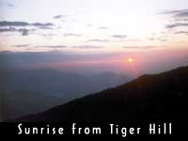

The Observatory Hill: Apart from the magnificent view it commands, this hill atop the Mall also is attached with great religious importance as a revered temple complex for both the Hindus and the Buddhists.

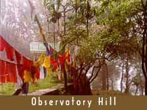

Darjeeling Himalayan Railway or the Toy Train: A visit to Darjeeling is incomplete without a ride in the toy-train of Darjeeling Himalayan Railway (DHR). The miniature train, given heritage status by UNESCO, covers the distance of 88 km between New Jalpaiguri station and Darjeeling. This fascinating narrow gauge steam engine train still operates with the original steam engine and the loops and the zigzags along the route are remarkable feats of engineering. The journey from New Jalpaiguri may be a pleasant experience but it is the short ride from Darjeeling town to Ghoom, the nearest station that becomes a joy ride in itself. The Toy Train is considered an engineering marvel and some prefer to call it one of the wonders of the world, to be preserved forever.
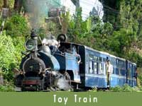

Batasia Loop and the War Memorial: About 5 kms. from Darjeeling, this railway loop is a marvelous feat of engineering and with its magnificent view of Darjeeling town with the Kanchenjunga mountain is worth an experience, whether aboard the Toy Train or just watching the Toy Train pass through this loop. The War memorial is constructed in the memory of the brave sons of Darjeeling who died for the country since Independence in 1947.
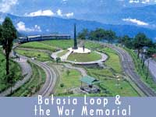
Tea Gardens: While in Darjeeling a visit to any nearby Tea Garden to watch the actual process of the manufacturing of Darjeeling Tea is worth it. Some of the Tea Gardens also sell their packet teas. There are about 70 tea gardens in this hill region and the most accessible one is the Happy Valley Tea Estate, which is about 3 km from the town or within a walking distance of about 40 minutes (Closed on Monday).
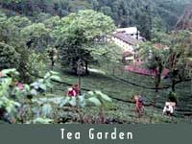

Buddhist Monasteries: In and around Darjeeling there are important and interesting Tibetan Buddhist Monasteries. The oldest one is called the Yiga Cholling Monastery which is situated about 8 km from the town at Ghoom and enshrines an image of 'the Coming Buddha' or the Maitriya Buddha. It was constructed in 1875 and belongs to the Gelugpa Sect. The Samten Cholling Monastery is another interesting monastery nearby. The Drukpa Kargyud Monastery, also known as Dali Monastery, is a big monastery located 5 km from the town. It belongs to the Drukpa Sect and the Drukchen Rimpoche resides here. The Bhutia Busty Monastery is situated at C.R. Das Road and is within 15 minutes walk from the Mall.
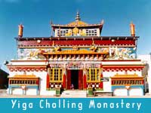
Japanese Peace Pagoda: The Nipponzan Myohoji Buddhist inaugurated the Japanese Peace Pagoda in 1992. It is a recent landmark constructed by Japanese Monks and commands an excellent view of the town and the Himalayan Range.
Dhirdham Temple: Situated just below the Railway station the temple is a structural replica of the famous 'Pashupatinath'' temple of Kathmandu, Nepal.
The Mall and Chowrasta: The Mall road originates and culminates at the Chowrasta which is the hub of Darjeeling town, a square on the ridge of Darjeeling town and a good place to sit and relax. It is ideal for a leisurely walk around a setting that is perfect. A walk around The Mall is a must just at any time of the day with the pleasant view of the mountains, valleys with rhododendron trees and old houses.
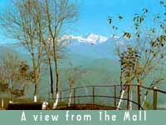
Bengal Natural History Museum: While taking a walk in The Mall a visit to the Museum of Natural History which lies close by is worthwhile. This fine small museum exhibits a unique collection of the fauna of the Himalayan region, especially of the Eastern Himalayas.
Himalayan Mountaineering Institute: It was founded in 1954 after the historic conquest of Everest on the 29th of May in 1953, when two people set foot atop Mount Everest. They were Tenzing Norgay Sherpa from Darjeeling and Sir Edmund Hillary from New Zealand. As an honour to the great Sherpa this Institute was formed with the aim of imparting mountaineering skills to all the enthusiasts. Tenzing Sherpa himself was one of the founding members and also the Field Director of the Institute.
It is situated on Jawahar Parbat and adjoins the Zoo. This Institute also houses a mountaineering museum which holds a rare collection of mementos from various Everest expeditions like equipments used by Tenzing Norgay and Edmund Hillary on their way to Mt. Everest and a letter written by George Mallory, the British climber who was lost while climbing Mt. Everest and whose body was found just a few years back. Nawang Gombu, the first man to have climbed the Everest twice is presently the Chief Advisor for the Mountaineering Training.

Himalayan Zoological Park and Snow Leopard Breeding Centre : About 2 km. from the town, this high altitude wild life park and new home of India's only collection of the Siberian Tiger, Himalayan Black Bear, Barking Deer etc. Padmaja Naidu Himalayan Zoological Park or the town Zoo exhibits some rare Himalayan Fauna including the Snow Leopard, Red panda, Tibetan Wolf, Himalayan Pheasants, etc. It is a treat for all wild life enthusiasts. Just nearby is a very successful Snow Leopard Breeding Centre.

Lloyds Botanical Garden: This is a colorful garden situated just below the market. In 1878 Mr. W. Lloyd gifted 40 acres of hillside to make a garden with local plants and flowers. It still has the most varied collection of rhododendron, magnolia, orchids, etc. of the Eastern Himalayas. It also has a glass-house full of alpine flowers and also features an Orchidarium and a collection of medicinal plants.
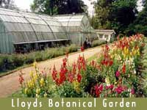
Darjeeling Rangeet Valley Passenger Ropeway: This Ropeway is in one of the most beautiful part of the town and is situated at North Point about 3 km from town. The cable car ride takes 6 passengers at a time and it passes over the lush green tea gardens with breathtaking view of the mountains (Kanchenjunga) and provides an experience that cannot be easily forgotten. The valley has glorious views of Sikkim and the river Rangeet.
Handicrafts: Darjeeling has some interesting places to watch the local handicrafts being made as well as a various range of choice handicraft souvenirs. The Tibetan Refugee Self Help Centre is a self-supporting Centre for Tibetan refugees which manufacture some intriguing Tibetan handicrafts. Established for the rehabilitation of Tibetan refugees who had followed the Dalai Lama to India in early 1959. It offers a wide choice of Tibetan handicrafts; Tibetan woollen carpet is very popular. Hayden Hall, a Roman Catholic social service centre also has a handicraft section with the purpose of helping the local poor people.


Ava Art Gallery: Approximately 10 minutes by taxi from the motor stand, it is just below the main road on the way to Ghoom. This gallery houses fine art and embroidery work of Mrs. Ava Devi.

PASSENGER ROPEWAY is another tourist attraction in Darjeeling has been the ropeway. This was the first ropeway in India. It connects the North point (7000 ft) to the Singla Bazaar (800 ft). The rope covers a distance of 8 kms in 45 minutes. The seats in the rope way is limited and it is better to get the tickets in advance. The ropeway is exciting and unique for any one visiting Darjeeling.
Hotel Viceroy (Darjeeling)
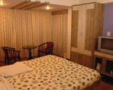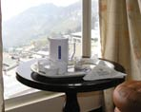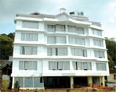
Viceroy is situated in the heart of Darjeeling, The geographical location of Viceroy Hotel. Restaurant is as below :

87 kms From N.J.P Railway Station.
88 kms from Bagdogra Airport.
0.5 kms from Darjeeling Bus Station.
0.5 kms from Darjeeling Railway Station.
400 Meters from the Mall Road.
200 Meters from Shopping Mall & Multiplex.
VICEROY HOTEL.RESTAURANT
17, Gandhi Road
Darjeeling, 734101
West Bengal
India. PH : 91-354-2256165, 91-94340 36036 E-Mail : viceroydarj@sify.com

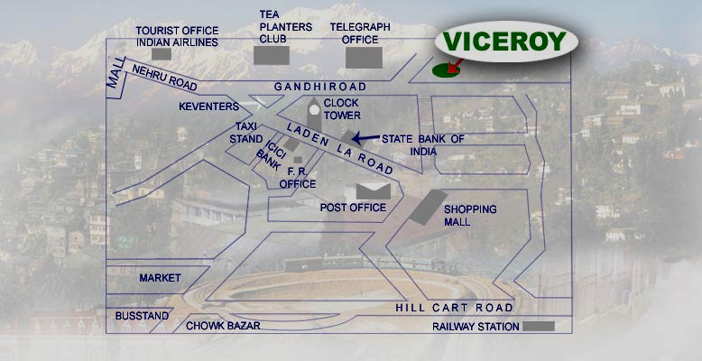
Gangtok
Population:50,000
STD Code: 03592
Area: 15 ² km (approx.)
Elevation: 5,480 ft (1780 m)
Climate:
SUMMER:
Min: 13º C
Max: 21º C
Annual Rainfall: 3894 mm
Best Tourist Season: April to Mid-June; Mid September to November
Best Mountain Views: Mid Sept. - Mid Dec.
Recommended Clothing: Light woollens and tropicals in summer (umbrellas and raincoats are useful) and heavy woollen in winter.
Language Spoken: English, Nepali, Hindi, Bhutia, Lepcha and Tibetan

Places of interest in Gangtok

Government Institute of Cottage Industry
Distance - km (from Gangtok)
Note - closed on Sundays, all government declared holidays, second Saturdays and the odd unforeseen holidays.
Phone No -
It is now known as the Directorate of Handicrafts and Handlooms as well as the Government Institute of Cottage Industries (GICI). Started during the time of the Chogyals of Sikkim, as a venture to preserve, protect and propagate the authentic Sikkimese arts, handicrafts and skills of local and village artisans, it has become one of the major attractions for people visiting Sikkim where beautiful souvenirs like carpets, hand carved tables (choktses), traditional handcrafts, furniture, handlooms carpets and other products are produced & exhibited for sale. A word of caution to the innocent guest. This institute is located at about half a kilometer uphill from the main market of Gangtok. It was established with the purpose promoting the manufacture and sale of local handicrafts. Thangkas, hand carved wooden tables -known as Choktsees and exquisite woven woolen carpets.
More than hundred student workers turn out cottage crafts adhering strictly to authentic Sikkimese designs. The carpets produced here, with textures, plush and exotic, the designs varying from sophisticated simplicity to a brilliant riot of vermilion pitted against intense blue, are durable and popular allover the world. Second to carpets in popularity is Sikkimese hand-made paper. Other products are Sikkimese thangkas, variegated appliqué work, batiks and exquisite dolls, in wood-work are available intricate carved Sikkimese tables, hand-painted masks, lamp-stands, shade and bamboo-craft. Esoteric masks, flashing silks, opulent brocade, and embroidered boots, clothes for the Sikkimese dancers.

Sikkim Research Institute of Tibetology (SRIT):
Distance - km (from Gangtok)
Entry Fee - Rs
SRIT has since become one of the most prestigious depository of Tibetan literature, rare manuscripts, paintings, thangkas, statues and religious objects and other works of art and history.
This institute was established to promote research on the language and traditions of Tibet as well as the Mahayana sect of Buddhism. There are about 30 thousand volumes, mostly xylographs, (xylographs are documents that are printed using wooden slabs that have the matter embossed on them in the reverse) translations of the original teachings of the Lord Buddha, and treatises by distinguished Buddhist scholars from different parts of the world. The museum at the Institute consists of rare collection of antiques like statues, coins and thangkas which are scrolls with paintings on them. This institute is a premier institute in the world that conducts. research in the language and culture of Tibet. It has on its faculty eminent scholars.
The library and museum of the Institute are open to the public on all days including holidays and Sundays. An entry fees of Rs 2/- is charged. The foundation stone of the Institute was laid in February 1957 by the Dalai Lama and if was inaugurated by Pandit Jawaharlal Nehru in October 1958.

Do-Drul Chorten (Stupa):
Distance - km (from Gangtok)
encircled by 108 prayer wheels built by late Trulsi Rimpoche in 1945-46. This is one of the most important and biggest stupas found in Sikkim. The Do-Drul Chorten or Stupa was built by the venerable Trulshi Rimpoche, head of the Nyingma order of Tibetan Buddhism in 1945. Inside this stupa, there are complete mandala sets of Dorjee Phurba (Bajra Kilaya), a set of Kan-gyur relics (Holy Books), complete 'Zung' (mantras) and other religious objects. Around this Chorten, which is one of the most important stupas in Sikkim, are 10 Mani-Lhakor (prayer wheels). These prayer wheels are turned by the devout Buddhist while chanting "Hail to the jewel in the Lotus", to invoke the Buddhisattva. The Chorten is surrounded by Chorten Lakhang, where there are two huge statues of Guru Rimpoche (Guru Padmasambhava).
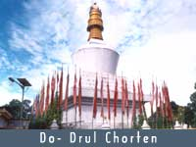

Deer Park:
Distance - km (from Gangtok)
This park which commands a good view of the hills surrounding Gangtok is perched on top of a hillside that plunges almost vertically deep into the valley. It was established in the late fifties and is located adjacent to the new Secretariat and is also called the Rustomji park so named after one of the Dewans of the Chogyal of Sikkim and the author of the book "Enchanted Frontiers". The park has a big open enclosure in which different types of deer can be seen. There are also a few cages in which some animal’s native to Sikkim like the Red Panda and the Himalayan Bear are kept. A big statue of Lord Buddha commemorating his preaching of the noble truths in the deer park at Sarnath adorns the park premises. A butter lamp perpetually burns in front of the statue which is surrounded by flowers of the most exotic variety. Below the statue, in golden letters is the following stanza from the works of the renowned scholar saint of Buddhism, Shantideva:

Shower forth, Ye Heavens sweet rains in season due,
That Earth's rich harvest swell in ample stream,
Holdfast, O' king, the path of righteousness,
That world on world may rise to bliss supreme.
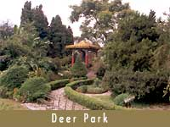

Permanent Flower Show:
Distance - km (from Gangtok)
Entry Fee - Rs.
White Hall, Close by the White Memorial Hall and just below the Palace Ridge park is the more recent Flower Show Hall. In recent years this show has become quite popular and famous as there are flower exhibitions throughout the year in accordance with the seasons and the flowers in bloom.

Enchey Monastery:
Distance - km (from Gangtok)
Located on a hilltop above Gangtok this monastery rebuilt in 1910 belongs to the Nyingmapa order and was once the hermitage site of Lama Drupthob Karpo renowned for his power of flying.
An important seat of the Nyingma order, the Enchey Monastery meaning the Solitary temple, was originally built with the solace that no other construction would be allowed near it is built on the site blessed by Lama Druptob Karpo, a tantric master known for his flying powers. This 200 year old Monastery has in its premises images of god, goddesses and other religious objects. Every year around January 'Chaam' or religious masked dance is performed with great fanfare for two days. it is situated adjoining the Sinolchu Tourist Lodge, 3 kms from Gangtok Town

White Hall:
Distance - km (from Gangtok)
The White Hall has historical value and is situated on the Ridge. It is a two storied structure and has typical British architecture and was built in 1932. It is so called not because it is, painted white but because it was built in memory of the first Political Officer of Sikkim, Claude White. There is an Officers' Club and a badminton court in the White Hall.
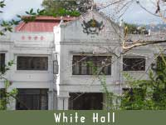

Ridge Park
Distance - km (from Gangtok)
The Ridge is a small stretch of plain and flat road above the town of Gangtok. It is just about fifteen minutes walking from the main market. The Ridge has the White Hall and the Chief Minister's official residence, known as the Mintokgang, meaning "blossomed crowned hilltop" on one end and the beautifully designed Palace Gate with a pagoda rooftop on the other end. A statue of Nehru, the late Prime Minister of India, adorns the roundabout above White Hall. Situated on the Ridge is also a resting shed using Tibetan architecture.

The ridge is lined with plants and trees which when in bloom are a riot of colors. Flower shows which attract tourists from all over the world are held just below the Ridge. From the ridge, the, road winding its way up along the Chola range towards Nathula (border between India and China) can be clearly seen. During 1967 (not 1962, when this border was quiet), a confrontation broke out between India and China at Nathula. Long ago, a small market called the Sudder Bazaar consisting of a few shops lined the Ridge. In the early twenties this market was shifted to the present M.G. Marg.

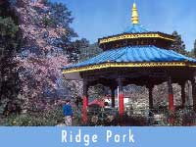

Tashi View Point
Distance - km (from Gangtok)
was built by the late King of Sikkim, Tashi Namgyal, it is situated 4 km from Gangtok town from where one can have a clear view of opposite hills, besides Mt. Khangchendzonga. This site offers a breathtaking panorama of the majestic Mt. Khangchendzonga and surrounding hills. Built by the late King of Sikkim Sri. Tashi Namgyal, it is situated about six kilometres away from Gangtok on the North Sikkim Highway, this place offers an astounding view of the Khangchendzonga snowy range on a clear day. On the opposite hill, the Phodong and the Labrang monasteries can be seen. A resting shed and a small cafeteria situated at Tashi View Point provides shelter and other amenities to the tourists. A park above the View Point is a good place to enjoy a picnic.
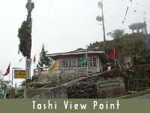
Hanuman Tok:
Distance - 5½ km ( from Gangtok )
Altitude - 7,200 ft.
Situated about 5 km uphill from White Hall on a bifurcation road of the Gangtok-Nathula Highway, is a temple devoted to Hanuman, a God worshipped by the Hindus. On selected points on the road to the temple, breathtaking views of Gangtok and the adjoining rolling hills can be seen.
From the temple itself, the snowy peaks of Khangchendzonga present a panoramic picture. One also gets a bird’s eye view of the Selep waterworks, which supplies drinking water to the Gangtok town, a few hundred feet in altitude below Hanuman Tok. The temple at Hanuman Tok is maintained by a unit of the Indian Army and can be found to be spick and span.
A short distance before the stair case leading to the Hanuman Temple is the cremation ground of the erstwhile royal family of Sikkim. The cremation ground has stupas and chortens each marking the place where the mortal remains of the departed souls were consigned to the flames.

Ganesh Tok:
Distance - Km (from Gangtok)
Altitude - 6,500 ft.
It is a very small temple dedicated to Lord Ganesh, a diety worshipped by Hindus. The temple is so small in size that it can hardly accommodate one person and one has to crawl to get inside it. It is located on the hill adjoining the TV Tower. It is on a hillock on Gangtok-Nathula Road. From here you can get a panoramic view of Gangtok town and the Raj Bhawan Complex and on a clear day you get a breathe taking view of Mt. Khangchendzonga.
During the tourist season, a small cafeteria is opened for the convenience of the visitors. Just adjoining the Ganesh Tok is a pinetum garden containing pine trees. A walk on the footpath amongst the pine trees is refreshing.
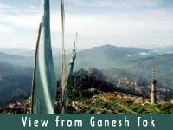
Himalayan Zoological Park:
Distance - km (from Gangtok)
Altitude - ft.
Entry Fee - Rs.
The park is located exactly across the road opposite Ganesh Tok and covers an area of 205 hectares. This area is also known as Bulbuley and extends almost up to Hanuman Tok. Although a 3 kms long jeep able road runs right through the park, vehicles are not allowed in. There is a paved cement path that passes by fenced open air enclosures housing the red pandas, Barking Deer, bears and other animals of Sikkim in a semi natural habitat. As the enclosures encompass a huge area the animals are sometimes not easily visible and one has to be patient to get a sight of them. Making noise drives away the animals to take refuge behind bushes.

Sa-Ngor-Chotshog Centre:
Distance - 5 km (from Gangtok)
Located on a beautiful hill top it is a Tibetan refugee monastic institution established in 1961 by his Eminence Luding Khen Rimpoche, Head of Ngorpa, sub-sect of the Sakya Order, with the blessing of H.H. Sakya Trizin and H.H. the Dalai Lama. This is the only monastery of the Sakya Order of Tibetan Buddhism in Sikkim.
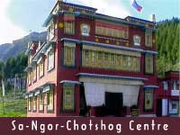

Rumtek Dharma Chakra Center
Distance - 24 km (from Gangtok)
Built in - 1960
A short drive from Gangtok will take you to Rumtek Dharma Chakra Centre. Built in 1960 by His Holiness the late 16th Gyalwa Karmapa it is a replica of the original Kagyurpa Monastery in Tsurphu, Tibet, the seat of His Holiness the Gyalwa Karmapa Rinpoche, head of the Karmapa sub sect of Kargyudpa order of Tibetan Buddhism. It now functions as the headquarters of the Dharma Chakra Religious Centre.
Located within the complex are the main monastery, the memorial stupa of the XVI Gyalwa Karmapa inlaid with gold plate and semi precious stones, Shri Nalanda Institute for Higher Buddhist Studies and the Jamyang Khang Primary School. The centre houses some of the world's most unique religious scriptures, manuscripts and religious art objects.
A fifteen minute walk downhill from Dharma Chakra Center takes one to the Old Rumtek monastery which was originally built in 1730 by the ninth Karmapa but was destroyed by fire and had to be reconstructed to the present state. His Holiness late Gyalwa Karmapa lived in this monastery till the completion of the Rumtek Dharma Chakra Center.
For more information visit their website at www.rumtek.org
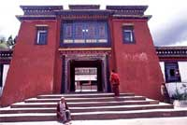
Jawaharlal Nehru Botanical Garden:
Distance - km (from Gangtok)
Located very close to Rumtek Monastery just half a kilometer before reaching Rumtek Monastery on the highway, it is maintained by the parks and Gardens unit of the Forest Department of the Government of Sikkim, the Garden is an enchanting and soothing experience among the lush green vegetation, rare plants and trees and certain species of Himalayan flowers and Orchids.
This garden is a mixture of well tended tropical and temperate plants and trees can be found here. A huge greenhouse containing many species of orchids has been constructed within the garden. For children there is even a small playground with a merry-go-round, swings and a see-saw. A cemented footpath winds its way through the garden and is good for taking a relaxed stroll. The sprawling town of Gangtok can be seen on the hill opposite. The garden is indeed an ideal picnic spot.

Saramsa Garden/ Ipecac Garden:
Distance - 14 km (from Gangtok)
Entry Fee - Rs.
Also know as lpecac Garden, the home of Sikkim's most exotic orchids and other rare tropical and temperate plants. The garden is know as Ipecac garden because of the plant Ipecac that is grown here. Established and maintained by the Department of Forest, it is an excellent recreation and picnic spot. Besides this plant, this garden also contains a wide variety of other flora including numerous types of orchids and medicinal plants.
A large green house also accommodates many other species of plants. One has to take a taxi to reach this place.
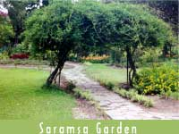

Tsomgo/Changu Lake:

Distance - 40 km (from Gangtok)
Altitude - 12,210 ft
Note - A must visit for all tourists.
The drive from Gangtok takes about 2½ hours by bus. The lake is about 1 km. long and oval in shape, 50ft deep. This is an alpine zone and snowbound from December to April and the lake is regarded extremely Holy holy and head of all lakes in Sikkim remains frozen from January to April, and attracts 99% of tourists visiting Gangtok, Sikkim. It is also a home of Brahmini ducks besides stopover for various migratory ducks. A lake at 12,310 ft? Impossible you will say but it is a fact. Tsomgo (Changu) lake is situated 35 km from Gangtok on the Gangtok - Nathula highway which forms a part of the old trade route from India to China. Before 1962, caravans of mules carrying goods used to ply on this route. The stretch of the route just below Karponang, 15 kms from Gangtok was particularly dangerous. Its steepness resulted in many mules slipping to their death into the ravine below. Karponang
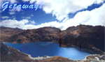

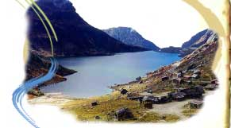

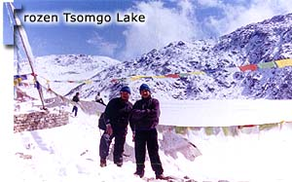
Nathula Pass:
Distance - 54 km (from Gangtok)
Altitude - 14790 ft.(4,392 m)
Note - The days for tourist visit is restricted and needs to be applied at least 24 hrs in advance and limited days of operation. The days permitted to visit Nathula are Wednesday, Thursday, Saturday and Sundays only. Photography is strictly prohibited in and around Nathula.
20 km further away from is the famed Nathula pass. The pass Nathula means the whistling pass. Nathula is the Indo-China border at Jawahar Lal Nehru Road whereby Indian troops and the Red army stand face to face. This is the closest an Indian Tourist can travel and pose a photo or two with the Red Army.
The pass Nathula means the whistling pass. The days for tourist visit is restricted and needs to be apply at least 24 hrs in advance and limited days of operation. The days permitted to visit Nathula are Wednesday, Thursday, Saturday and Sundays and permissible for Indian Tourists only.
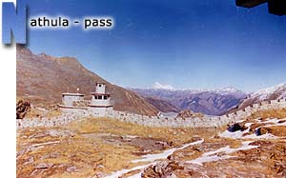
Menmecho Lake:
Distance - 60 km (from Gangtok)
This is another beautiful lake located twenty kilometres ahead of the (Changu) lake. Quite big in size, it lies cradled between the mountains below the Jelepla pass and is also the source of the river Rangpo-chu which meets the Teesta at Rangpo. Like the (Changu) Lake, it also derives its water from the melting snow around especially from the stream that originates just below the Jelepla pass.
The lake is famous for its trout and a farm to cultivate these fish also exists nearby. Accommodation for the visitors coming here is available at the dak bunglow and tourist lodge near the lake. Tourists are not yet permitted to visit this area.

Fambong La Wildlife Sanctuary:
Distance - 25 km (from Gangtok)
Altitude - 1280 - 2652 m
Note - A log house with two rooms is available at Golitar and Tumin. Charges are Rs. 50 per person per night
Entry Fee - Rs.5/- per head.
Best Season - October and April
It has an area of 51.76 sq. km. The main vegetation is Oak, Katus, Kimbu, Champ with thick bamboo forests and ferns. The Sanctuary is also home to a large number of wild orchids, rhododendrons etc. The richly forested area is known to be home for various species of wild animals and birds. This area is being developed as a short duration trekking trail.

Kyongnosla Alpine Sanctuary
Best Season to Visit April - August and October - November.
Kyongnosala Alpine Sanctuary is located at a distance of 31 km east of Gangtok on the way to Nathu La. Its present area of 31 sq km extends from 15th Mile police check post up to and along the Edges bordering Rong Chu and Tsongu Lake. The sanctuary is rich both in flora and fauna. Rare, endangered ground orchids and rhododendrons interspersed among tall junipers and taller silver firs are among the important plants present.

Rhododendron nevium the State Tree of Sikkim and Cypripedium tibeticum the ground slipper orchid on the verge of extinction have been introduced here.
The area is snow covered often up to May when primulas pop up through the snow and rhododendrons come into bud. By June July they are in full bloom. Flowering succession by the many species continues right through to October when Polygonum is the last to flower, dries up. First snowfall is normally by December - January.

Fambong Lho Wildlife Sanctuary
25 kilometers from Gangtok and at an altitude of 1280 to 2652 mtr., this 5176 hectare Sanctuary hosts Himalayan Black Bear, Red Panda, Barking Deer, Goral, Serow, Marbled-Cat, Clouded Leopard, Leopard-Cat and Civet-Cats along with various kinds of birds. The Binturong or Bear-Cat (Arctictis binturong) is a rare civet reported from here.
Best Season to Visit
March to late May and September to mid- December.
Sonam Palgey Hotel (Gangtok)

Originally built for royal guests during the coronation of Sikkim’s last King Palden Thondup Namgyal in 1963, Sonam Palgey, Gangtok, was christened ‘Elephant Mansion’ due to its being the largest structure of its time.

Snuggled comfortably amidst pine trees and alpine meadows, the establishments in Lachen and Lachung in North Sikkim offer the comfort and luxury required when venturing further North. The Sonam Palgey Chiminda International in Pelling, West Sikkim and the Sonam Palgey Aritar Retreat in East Sikkim make for the best stay one can ask for while relishing the vista of snow capped peaks and antique monuments that adorn Sikkim’s historical sites.

From foyer to the final curtain, a personalized Sikkimese hospitality is lavished upon all guests staying at Sonam Palgey properties, the largest, most reliable and luxurious chain of hotels in Sikkim.
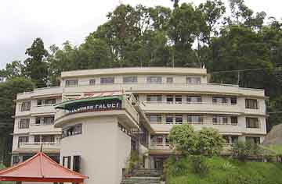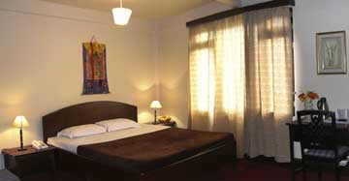

Central Reservation Office
Elephant Mansion,
Deorali, Gangtok
E. Sikkim - 737102
Telephones
+91-3592-281077 / 281078
+91-3592-281834 / 281870
Email: sikkim@sonampalgey.com
Pelling
Distance - 117 km (from Gangtok)
Altitude - 2,085 m
STD Code: 03595

Pelling, a quiet village in West Sikkimhouses the famous Pemayangtse Monastery and has now turned into a bustling tourist destination and has come up with numerous hotels and lodges. The pleasant little town of Pelling is famous for magnificent view of the snow-capped mountains of Kanchenjunga. Situated at an altitude of 6,800 ft, it offers good view of entire mountain ranges including the Koktang, Kumbhakarna, Rathong, Kabru, Dom, Kanchenjunga, Pandim, Zopuno, Shimbho, Narsing, Siniyalchu and others. Pelling is as close as you can get to Kanchenjunga without leaving the material comfort of good hotels and due to its advantageous location, many hotels and lodges have come up in and around Pelling offering various categories of accommodation.

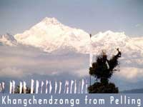
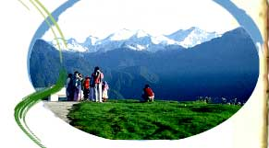

Places of interest near Pelling

Pemayangtse Monastery: Pemayangtse literally means 'Perfect Sublime Lotus'. This is one of the oldest and most important monasteries of Sikkim. Founded in 1705, this monastery belongs to the Nyingma-pa sect. The three-storied building of the monastery houses a good collection of wall paintings and sculptures.

On the third floor of the monastery, there is a seven-tiered painted wooden model of the abode of Guru Rimpoche, complete with rainbows, angels and the whole panoply of Buddha and bodhisattva. In January/ February every year, a religious dance called 'Cham' is performed in Pemayangtse.

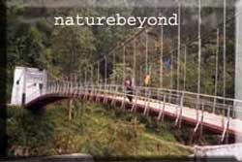

Khecheopalri Lake:
Distance - 24 or 33 km (from Pemayangtse)
Hotels: Trekker's hut has been provided by the Tourist Department. There is also a pilgrim's hut, managed by the Tourism Department, which is meant to provide accommodations to the people who come on pilgrimage tours.
This lake is also known as the wishing lake. This unusually tranquil lake, surrounded by verdant forest is considered as one of the sacred lakes of Sikkim both by the Buddhist and the Hindus and no water sport or other activities besides prayers are allowed around it. It is believed that birds do not permit even a single leaf to float on the lake surface. The vicinity of the lake is an ideal place to find the Lepcha Houses and their communities.

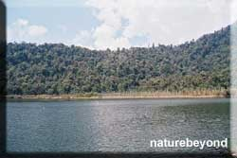
Rabdentse Ruins
This was the second capital of the erstwhile Kingdom of Sikkim after Yuksom and till the year 1814 AD, the Kings of Sikkim had ruled the State from this place. Today, the ruins lie hidden from the main road at a walking distance from the Pemayangtse Monastery. The scenic view from the top of the ruins scanning across the deep valley to the mystic heights of Khangchendzonga ranges is something to be cherished and etched in memory.

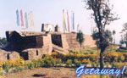

Yuksam/ Yuksom
Distance - 124 km (from Gangtok); 40 km ( from Pemayangtse )
Altitude - 1780 m
STD Code:
Hotels: Hotel Tashigang
The hamlet of Yuksam is set amidst pristine hills and lakes, where according to the historical records and it was here in 1641 AD the first Chogyal (King) Phuntsok Namgyal of Sikkim was consecrated by the three wise lamas. Yuksam literally means the meeting place of the three learned monks. This was the first capital of Sikkim. The Norbugang Chorten and the Coronation throne are the silent witnesses to the event of 1641.

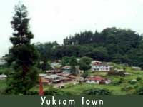

Tashiding
Distance - km (from Gangtok)
STD Code: 03592
Hotels: Siniolchu Guest House.
About 16 km away from Yuksam and about 40 Kms from Gyalshing, via Legship is this important monastery belonging to the Nyingmapa order. It was built on the top of a hill that looms up between the Rathong river and the Rangit river, where a rainbow emanating from Mount Khangchendzonga came to an end. At first only a small Lhakhang was built by Ngadak Sempa Chempo in the 17th Century. The main monastery was built by Pedi Wangmo during the reign of Chakdor Namgyal and some of the statues built then still exist. The sacred objects of worship in Tashiding are the chorten Thongwa Rangdol and Bumchu (holy water). The chorten was built by the Lhatsun Chenpo and it is believed that merely to view the chorten is enough to cleanse one of all sins. Carved skillfully on flagstones surrounding the monastery are holy Buddhist mantras like 'Om Mane Padme Hum' by the master craftsman Yanchong Lodil.

The heart of Sikkimese Buddhism as Guru Padmasambhava considered so and houses the Tashiding Monastery along with Sacred Thongtwa Chorten. It’s so holy that even a slight glimpse of cleanses all sins. Rich environment flooded with oranges and cardamoms and gateway to Borong hot springs, ideal for soft treks and perfect Sikkimese village in the setting.
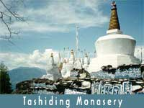
Uttaray
Distance - km (from Gangtok)
STD Code: 03595
Small hamlet situated at the extreme southwest corner of Sikkim. Base camp for Singalila trek.
Barshay/ Versay:
Distance - km ( from Gangtok )
Altitude - 10500 ft.
Rest House: Shambala Village Resort.
Located in the extreme west is noted for rhododendrons. It's a huge Rhododendron forest, is a must visit experience trip during the flowering season from mid march to April end. The whole forest is aflame with riot of Rhododendron Flowers with hues raging from blood red to pure white and against the back drop of the mountains its truly an unforgettable experience. The Barsey Rhododendron Sanctuary lies in the south west corner of the West Sikkim district. Spreading over 104 sq. km, across the razor sharp Singalila Range, which forms the natural international border with Nepal. In the South the Rambong Khola separates it from West Bengal. There are three points of entry, Hilley, Dentam and Soreng. Tourists generally prefer Hilley since it is approachable by road. The bridle path from Hilley to Barsey already exists and is favorite amongst tourists especially during the Rhododendron flowering season.
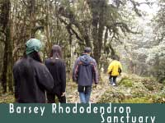

Biksthang:
Distance - 119 km (from Gangtok)
Altitude - 4200 ft.
STD Code: 03595
Hotels: The Bliss Resort (252284/252285)
A short distance from Pelling is the small hamlet of Biksthang. Also know as Chuchen and Mangalbaray, calm, serene and tranquil natural surrounding is the main attraction of Biksthang. It is a new and upcoming tourist destination in West Sikkim and you can watch the majestic Khangchendzonga and its lesser peaks standing tall from dawn to dusk on a clear day.
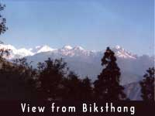
Legship
Distance - km (from Gangtok)
Altitude - ft.
STD Code:
Hotels: Hotel Trishna, Siniolchu Guest House
This gateway to western Sikkim, has a holy Hindu Shrine of Lord Shiva on the banks of river Rangit. A must visit for all tourists specially the Indian Travelers. The festival of the temple takes place in the month of November known as the Bala Chaturdesi. Legship also houses the first ever built dam in the state for hydro electricity purpose. The water accumulated in the dam is used for Rangit Water World and local folks come here for picnics and rafting.

Sanga Choeling Monastery
Built in 1697, Sanga Choeling means 'the island of esoteric teaching'. 45 minutes walk from Pelling and 7 km from Pemayangtse will take you to this second oldest monastery in Sikkim. A 4 km trail rises from the playing fields just above Pelling to reach the small monastery of Sanga Choeling is one of the oldest gompas in Sikkim. This gompa is another of Lhatsun Chenpo's creations, and is highly venerated among the Nyingmapa. Gutted by fire, it has been rebuilt and houses some of the original clay statues.

Rinchenpong:
Distance - km (from Gangtok
Altitude - ft.
STD Code:
Hotels: Rinchenpong Village Resort
The upcoming tourist spot in the western part of Sikkim, has a magnificent command over the mountain views, sunsets and rise, flora and fauna, village tourism ,historical sites and heritage of Resum Monastery, old as time. Rich forests and ample area for soft treks.

Reshi Hot Springs:
Distance - 25 km (Gyalshing)
These hot springs are located near Reshi on the River Rangit. One has to walk about ten minutes from the highway across the river Rangit by a pedestrian bridge to reach the hot springs. The water of these springs has medicinal value as it contains sulphur and can cure some skin diseases. People from all over the state and neighboring Darjeeling come here during the winter months and spend days together lying submerged in the soothing water of the hot spring. There are a couple of trekker’s huts for the convenience of the tourists. These springs also considered very holy as one of the four holy caves is located here. This holy cave is called the Kadosang Phu or cave of the occult fairies and lies on the south of the four cardinal points.

Siliguri and New Jalpaiguri

These twin Cities of Siliguri and New Jalpaiguri are the departure point to Darjeeling, Sikkim and the North Eastern States. Being the nodal point this place has become very busy and crowded. This area has got population over 2.5 lakh people. Siliguri also acts as a transit point for Nepal. This place is not very pleasant to stay as there are always long lines of buses and trucks. These trucks and vehicles might be good for business but they provide very ugly sight. Tourists come to Siliguri and New Jalpaiguri mainly to change bus or catch trains. If you have time then visit the almost forgotten wild life sanctuary of Jaldhapara. The best season to visit this park is between October and May. This the time when the new grass has come up and animals are out there. The sanctuary has elephants, dears, tigers and other animals but the main attraction is the Rhinos which are threatened by the poachers. Elephant Safari can be taken from Hollong.

More Information On Sikkim

Area: 7,096 sq km
Population: 5,40,543(approx) as per 2001 census
Capital: Gangtok
Languages: Nepali, Bhutia, Lepcha, Limbu, Hindi, English, Bengali.
Literacy Rate: 69.68%

THE ENCHANTED LAND

A journey to Sikkim necessarily involves awakening the senses and discovering the pristine and mystic beauty of the land. What one will find most fascinating is the journey itself-a continuum of sights, sounds, and feelings. Sikkim is a dreamland that one can realize and enjoy, now that the area is open to all. It is a state cloaked in the mystery of remoteness, well perched in the hills in a horseshoe formation, with mountains varying in altitude and cut off from the din and bustle of the modern world.

GEOGRAPHICAL INFORMATION

Location & Topography: Located in the eastern Himalayas, Sikkim is bounded by Tibet (China) in the north, West Bengal in the south, Tibet and Bhutan in the east and Nepal in the west. The state is spread below Mount Kanchendzonga (8534 m), the third highest peak in the world. The locals worship the mountain as a protective deity. The elevation of the state ranges from 300 m to over 8540 m above sea level.34% of Sikkim Geographical is is under protected areas. Climate Due to the extreme altitude, there is an immense variation in climate and vegetation. With a rainfall of about 140 inches in Gangtok, the climate is tropical up to 5,000 ft, temperate between 5,000 ft-13,000 ft, alpine at 13,000 ft, and snowbound at 16,000 ft. The best time to visit Sikkim is between mid-March and June but especially, April and May, when the rhododendrons and orchids bloom. However, temperatures can be high, especially in the valleys. During the monsoons, from the end of June until early September, rivers and roads become impenetrable, though plants nurtured by the incessant rain erupt again into bloom towards the end of August. October, when incessant rain erupt again into bloom towards the end of August. October, when orchids bloom once again, and November tend to have the clearest weather of all. As December approaches, it gets bitterly cold at high altitudes, and remains that way until early March, despite long periods of clear weather.

FLORA AND FAUNA
The gigantic mountain walls and steep-wooded hillsides of Sikkim are drained by torrential rivers such as the Teesta and the Rangit, and are a botanist's dream. The lower slopes abound in orchids. Sprays of cardamom carpet the forest floor, and the land is rich with apple orchards, orange groves and terraced paddy fields. The Tibetans used to call this Denzong, "the land of rice." At higher altitudes, one can find huge tracts of lichen-covered forests, where every conceivable species of rhododendron and giant magnolia trees punctuate the deep cover. Higher still, approaching the Tibetan plateau, dwarf rhododendron provide vital fuel for yak herders. Snow leopards, Himalayan black bears, tahr (wild ass), bharal or blue sheep, and the endangered red panda, the symbol of Sikkim, inhabit the forests. Avian life too is abundant with the giant lammergeyer, vultures, eagles, whistling

HISTORY
Buddhism, the major religion in the state, arrived from Tibet in the 13th century. It took its distinctive Sikkimese form four centuries later, when three Tibetan monks of the old Nyingamapa order, dissatisfied with the rise of the reformist Gelukpas, migrated to Yoksum in western Sikkim. Having consulted an oracle, they sent to Gangtok for a certain Phuntsog Namgyal, whom they crowned as the first Chogyal or "Righteous King" of Denzong in 1642. Both the secular and religious head, he was soon recognized by Tibet, and brought sweeping reforms. His realm was far larger than today's Sikkim, taking in Kalimpong and parts of western Bhutan. Over the centuries, the territory was lost to the Bhutanese, the Nepalese and the British. The British policy to diminish the strong Tibetan influence resulted in the import of workers from Nepal to work in the tea plantations of Sikkim, Darjeeling and Kalimpong and these soon outnumbered the indigenous population. After India's Independence, the eleventh Chogyal, Tashi Namgyal, strove hard to prevent the dissolution of his kingdom. Officially, Sikkim was a protectorate of India, and the role of India became increasingly crucial with the Chinese military build-up along the northern borders that culminated in an actual invasion early in the 1960s. His son, Palden Thondup, was a weak ruler. The beleaguered Chogyal eventually succumbed to the demands of the Nepalese majority, and Sikkim was annexed by India in 1975.

PEOPLE
Ethnicity Sikkim is the least populated state in the country. There are three principal communities of Nepalis (75%), Lepchas (20%), and smaller proportions of Bhutias and Limbus. Lepchas or the Rong appear to be the original inhabitants of Sikkim as no legends of their migration are available. In the 13th century, the Bhutias from Kham area of Tibet came to the state. They believed in Buddhism of the Mahayana sect. The Nepalis were the last to enter in the mid-19th century. All communities live in perfect harmony sharing each other's culture, ethos, and traditions with the result that there is now a Sikkimese culture, which is composite of all the three prominent communities. Most of the people speak Nepali, which is also the state language. It is the harmony of the place that provides justification to the name of the state derived form Sukhim, meaning "happy home, a place of peace." Though Hinduism is equally followed, Buddhism is entrenched in the tradition of the state. The people have faith in the Buddha, the dharma (his teachings), and the sangha (assembly of monks) where religious texts are studied, taught and preserved. Soaked in the religious tradition, the land has a spiritual ambience where prayer flags with inscriptions of Buddhist texts flutter around the boundary of the village to ward off evil spirits, prayer wheels rotate to the currents of water, and chortens and lucky signs are common sights. The protector deity is the goddess of Kanchenjunga that stands erect as a sentinel protecting the peace of the state. The deference is so deep and abiding those adventurers is not permitted to scale the top of the peak. Their achievement is acknowledged by reaching somewhere close to the top. Since the hills cannot be animated, anthropomorphism enables these to be depicted in masks.

MUSIC & DANCE
Sikkim's famous mask dances provide a marvelous spectacle. Performed by lamas in the Gompa courtyard to celebrate religious festivals, these dances demonstrate perfect footwork and grace. Costumed lamas with gaily-painted masks, ceremonial swords and sparkling jewels, leap and swing to the rhythm of resounding drums, trumpeting of horns and chanting of monks. Saga Dawa is a very auspicious day for the Mahayana Buddhists. On this day, people go to monasteries to offer butter lamps and worship. A huge procession of monks goes around Gangtok with holy scriptures. Kagyat dance is performed every 28th and 29th day of the Tibetan calendar. The solemn nature of the dances is interspersed with comic relief provided by the jesters.

FAIRS & FESTIVALS
The people celebrate the anniversaries relating to birth, enlightenment, and nirvana of the Buddha, besides the Buddhist New Year and the harvest festivals. Several festivals are celebrated in Gangtok and its adjoining areas. The Buddhist festival of Bumchu is held in the Tashiding Gompa during January. The festival of Chaam is held in Enchey Gompa during January-February and is marked by dancing. Kagyat Dance is a mask dance held every month at Gangtok, Pemayangtse and Phodong. Losar marks the Tibetan New Year and is celebrated during February-March at Pemayangtse and Rumtek. Tse Chu is a Buddhist dance held in May at Rumtek. Saga Dawa (held in Gangtok during May) and Drukpa Teshi (celebrated statewide during July) mark Buddha's first teaching. Phang Lhabsol is a mask dance celebrated statewide during August. Dasain, celebrated during September-October, is marked by gift exchanges and animal sacrifice.

ATTIRE
Traditionally the Lepcha men wear tego, tomo (gyado) thokro, tingip nyiamrik, ban, thektu, while the women wear dungdem, tego thetuk, nyiamrik, and ngajo (sickle). The ornaments include chyap-chyap shambrang bur, kukip alyak, nay-kong, and akager. The women maintain their hair in two braids.
The traditional attire of Bhutia men consists of hentachi kho tied by kera gyaado jaja, thuri shyambo and shampo (shoes). Women wear hanju, kho (sleeveless) tied by kera, ceiling, shyambo, tapsu (hair band) and shampo. Married women wear pangden below waist in the front. The traditional ornaments comprise khow, kesung, nyandap, and diu. The women keep their hair in two braids. Nepalese males wear daura, suruwai, topi patuka (waist coat) and a khukri, while the women wear chowbandi choli, gunew tied by patuka, hembari (shawl tied round the chest) majetro. The ornaments include chyapte sun, gadavari (ear rings) tilhari kantha (hanging from the neck) chura, dungri, mundri (nose ring), kallis (ankle ornaments), sirbandi charrani har and tikmala are female ornaments. The sindur (vermilion) and the potey (bottle green) are the signs of married women.

Maps

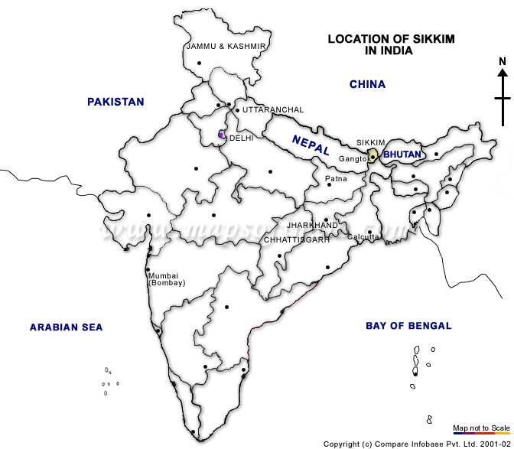

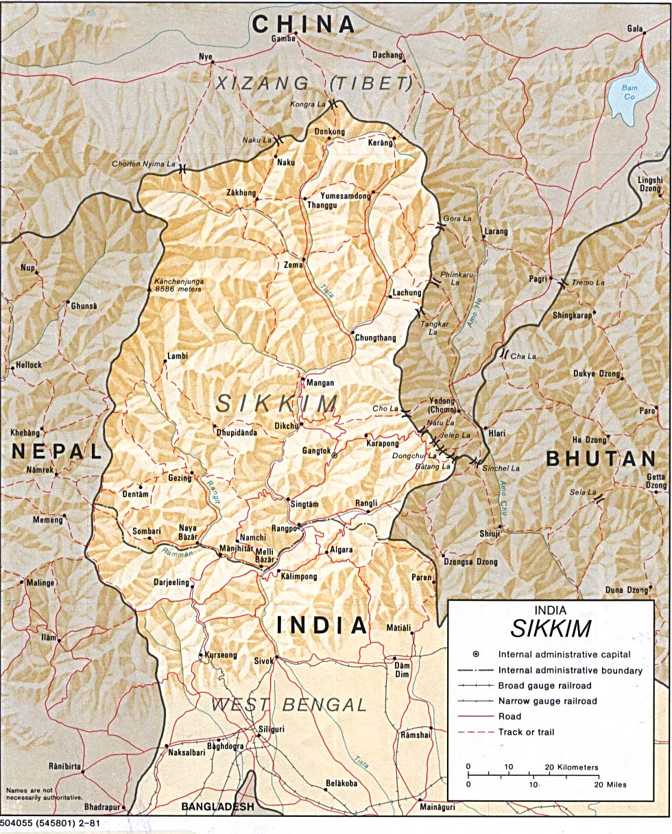

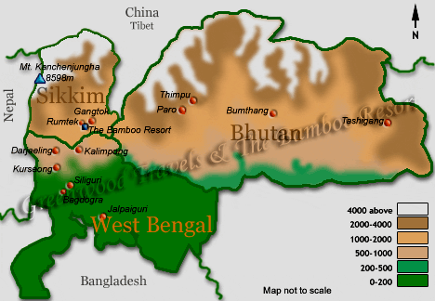

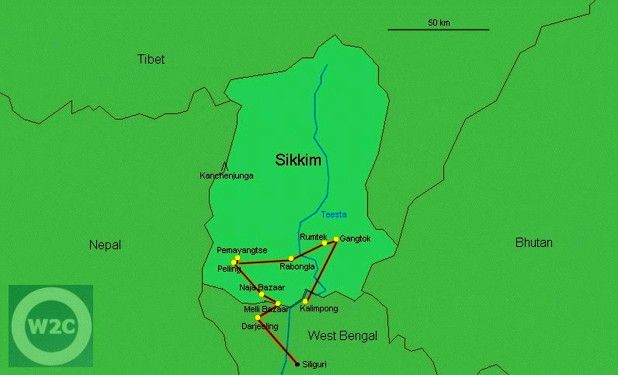

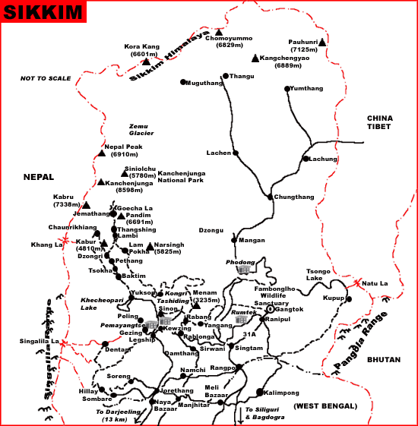

FAQ

nlike other hill stations in the Eastern Himalayan range like Darjeeling, Kalimpong, Gangtok and Mirik very little information is available on interior SIKKIM. In fact, most Travel Agents in the Western part of the country conduct tours of the Golden triangle of Darjeeling, Kalimpong and Gangtok. So, all the information on Sikkim revolves around its capital Gangtok. While meeting people interested in traveling to Sikkim, we were amazed at the level of interest that Sikkim generated amongst travel buffs. However, they were strapped for want of genuine information on the `what, where and how' of things pertaining to travel to Sikkim. The Wanderers, have endeavored to answer some basic questions on Sikkim.

1. Where is Sikkim?
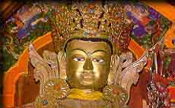
Ans: Deep in the Eastern Himalayas, between the kingdom of Nepal in the West and the kingdom of Bhutan in the East lies a small stretch of rugged land just 110 kms by 65 kms. This is the 22nd State of India-Sikkim. On its northern borders towers the formidable plateau of Tibet and it shares its Southern borders with West Bengal. The entire state of Sikkim is mountainous.

2. Is it a beautiful place?
Ans: Within an area of only 7,096 sq kms (slightly larger than Delhi and its suburbs), its hard to imagine the stupendous wealth of its natural beauty till you actually see it with your eyes. From the dense jungles of the Duars (meaning `gateway') that comprise its Southern borders to the mighty peaks towering in the North and always shrouded in snow and mist, Sikkim is not only beautiful but truly EXOTIC.The roaring Teesta river, the main river in Sikkim flows right across it in a North-South direction. In fact she welcomes you into Sikkim as she escorts you in the initial stages of your journey into Sikkim, enabling you to see the spectacular scenery en route. From almost every part of Sikkim, especially West Sikkim, you get to see the majestic Mt.Khangchendzonga, the 3rd highest peak in the world at 28,168 ft., casting her magical spell over the land and its inhabitants. The other lofty peaks in the West above 20,000ft are Kabru, Siniolchu, Pandim, Rathong, Kokthang, Talung, Kanglakhang, Simvo and Jonsang. In the East there is Mt. Paunhri at 22,000ft. On a clear day these serene peaks will gaze at the awestruck visitor exuding a charm that keep them coming back for more every year.
3. Which places should one visit in Sikkim?
Ans: Normally, people come to see the Golden triangle comprising Darjeeling, Kalimpong and Gangtok (the capital of Sikkim). They complete this trip in about a week's time ex-New Jalpaiguri (the nearest Railway Stn) or Bagdogra (the nearest Airport). But Gangtok is hardly Sikkim! There's so much to Sikkim than merely Gangtok. For your convenience we'll divide the places according to the four districts:

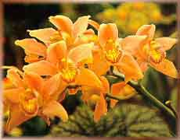
a) North Sikkim: This is perhaps the most spectacular region in all of Sikkim. This is wilderness country full of waterfalls and one should be willing to forsake luxury to visit places like Lachung (8,610ft) and Yumthang Valley at an altitude of 12,400 ft, where one can see 24 species of rhododendrons in bloom in the summer. In winters for over 4 months, the place is covered with snow. This is the home of the yaks and there is no civilian population here. The Govt has recently opened up Yumesamdong about 24 kms beyond Yumthang at an altitude of 15,000ft. The hot spring here on the river Sebu-Chu is even better than the one at Yumthang. Along with Yumasamdong the route to Lachen and Thangu have also opened up.To go there, you have to take the left bifurcation from Chungthang. Recently, a limited number of tourists have been visiting the spectacular, holy Gurudongmar Lake beyond Thangu at an altitude of 17,000ft.

b) East Sikkim: The places to see here are Gangtok, Tsongo (Chhango) Lake (12,400ft), Rumtek Monastery, Rangka Monastery, Martam village, Aritar. Beyond Tsongo Lake,very recently, the Govt has also opened the famous Nathula Pass on the Indo-China border as well as the alpine regions of Kupup, which has the world's 2nd highest Golf Course, as well as Menmecho Lake.
c) South Sikkim: Rabangla. Great day walks can be undertaken from here and the Damthang-Tendong trek and the Rabangla-Maenam trek are the most famous.
d) West Sikkim: This region offers spectacular views of the Khangchendzonga range from Pelling and Pemayangtse. Places like Yuksom are ideal for relaxation and hikes. The famous trek to Goechala, starts from Yuksom. Other places to visit are Khecheopari Lake, Tashiding Monastery and Singshore bridge. The Rabadantse Palace ruins and the Sanga Choeling Monastery make for good day hikes ex-Pelling.
The above are only indicative and have been mentioned considering the limited number of days one has in hand. Time permitting, there are so many more places that one could go to.
4. Do Indians require permits to visit Sikkim?
Ans: Indian nationals do not require any permit to visit unrestricted areas in Sikkim like Gangtok, Rumtek, Pemayangtse, Yuksom, Phodong etc. But for the following restricted areas Inner Line Permits (ILP) are required:
a) North Sikkim: Chungthang, Lachung, Yumthang Valley, Yumesamdong, Lachen, Thangu, Chopta and Gurudongmar Lake.
b) East Sikkim: Tsongo Lake, Nathula Pass, Kupup and Menmecho Lake. The ILP can be obtained from Sikkim Police, Gangtok. Any reputed travel agent will also organise the same for you. For Nathula Pass, Kupup and Menmecho Lake, small groups are now permitted to visit these with special permits from the Army.
5. What about permits for foreigners?
Ans: Foreign nationals would require a restricted area permit to visit areas that are unrestricted for Indian Nationals. Foreign Nationals are permitted to visit Gangtok, Rumtek, Phodong and Pemayangtse on the basis of their visas for a period of 15 days. Foreigners are also permitted to trek to the Dzongri area provided they are in a group of four or more. They are also allowed to visit Tsongo lake and Yumthang valley and Lachen provided they are in groups of four or more and sponsored by Indian travel agencies.

6. Which is the best time to visit Sikkim? Does it snow in Sikkim?
Ans: There are 3 seasons for visiting Sikkim.
a) Summer: The summer begins from mid-April and last till May. This is the time when the rhododendrons are in full bloom in places like Yumthang, Varshey (West Sikkim-2 day trek) etc. The skies are clear with occasional showers. This is one of the best times to go on treks.
b) Autumn: This is a great season when the skies are clear and the mountains are preparing for the onslaught of the winters. The snow clad peaks should now be visible with the air at its cleanest after 4 months of torrential rains.
c) Winters: This is the season for those who dare. A visit to Yumthang Valley in winters offers an awesome panorama of a wilderness under a sheet of snow. Tsongo Lake is frozen solid and remains that way till Feb-March. Even in early April one can frolic in the ice in Yumthang and Tsongo, although it doesn't snow there in April. But be warned, it's really cold out there!
Note: Avoid visiting Sikkim from mid-June to 10th September due to heavy rains and occasional landslides. However, the high rates of discounts offered by hotels and the sparse crowd in the monsoon are strong reasons for people to visit Sikkim during this time of the year also.

7. What about landslides?
Ans: Sikkim is a landslide prone area and in the monsoons many parts of Sikkim are cut off. The repairs are taken care of by the Border Roads Organisation (BRO), who do a great job of clearing the roads as fast as possible. With the border closeby, it is also imperative from the Defence point of view to keep the roads as clear as possible. But to be honest with you, a trip to Yumthang without wading through knee deep water in landslide zones wouldn't be half as exciting. `Transshipments' across landslides are common and can be an adventurous experience! Ask those who have travelled !

8. Okay, so how do I reach Sikkim?
Ans: Sikkim is well connected by rail and air to the rest of the country through Siliguri in West Bengal. There are no airports or railway stations in Sikkim. The primary means of transport within Sikkim is by road. To get to Sikkim you must first reach Siliguri.
a) By Air: The nearest airport is Bagdogra near Siliguri in West Bengal. It is connected by daily flights from New Delhi and 6 flights from Calcutta (excluding Thursdays) every week. It is 115 kms from Gangtok and takes about 4 1/2 hrs. Very recently a 4-seater helicopter service from Bagdogra to Gangtok has started and takes about 20min.
b) By Rail: The broad guage railway station is New Jalpaiguri.The Dadar Guwahati Express is the only direct train from Mumbai. One can also come via Calcutta or New Delhi. A luxury train travel would be to take the Rajdhani from Mumbai to New Delhi and by taking the New Delhi-Guwahati Rajdhani which passes over New Jalpaiguri.
c) From nearby hill stations: If you are planning a visit to Darjeeling, Kalimpong, Mirik or Bhutan, you can combine the trip with extentions to Sikkim or vice versa.
9. How good are hotels in Sikkim?
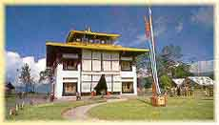
Ans: In Gangtok, you would get top of the line hotels like Nork-hill and Tashi Delek. Good 3 stars like Chumbi Residency (Rs. 900 + taxes) are also available. They are the best available in that range. Medium budget hotels like Mt. Simvo (Rs. 450 to 1100 + taxes) in Tadong away from the hustle and bustle of Gangtok are also there. In Rumtek, 24 kms from Gangtok, one could stay at Shambala Resort. At Martam village, 5 kms from Rumtek, one could stay at Martam Village Resort. At Aritar, a beautiful and quiet place in Rhenock, East Sikkim, 55 kms from Gangtok, one can stay at The Aritar Retreat.
In West Sikkim, the hotels are comfortable but not luxurious. In Yuksom, Hotel Tashigang (Rs. 900 + taxes) is a good place for relaxing for a few days. Similar hotels are there in Pelling, a moderately crowded town with stupendous views of the Khanchendzonga range.
In North Sikkim, the accommodation is very basic at Lachung, Lachen and Yakchey. But they are fairly comfortable and in log huts. It's a great experience to spend a couple of nights in them. There are rooms available with attached toilet, electricity, room heaters and warm water and blankets.

10. Some snippets?
Ans: Here are some interesting facts about Sikkim:
Population is 4.2 lacs. Density of population is 58 per sq km.
Some altitudes: Gangtok-5,800ft; Gyalsing-5,600ft; Namchi- 4,600ft; Mangan- 4,000ft; Tsongo lake-12,400ft; Chungthang-5,600 ft; Lachung-8,610ft; Yumthang- 12,000ft; Yumesamdong- 15,000ft; Lachen- 8,838ft; Thangu- 13,000ft; Choptha valley- 13,200ft;Dzongri-13,200ft; Goechala-16,200ft.

Population of Buddhists- 28%, Hindus-67%
State animal-red panda; state bird- blood pheasant; state flower- Nobile orchid; state tree- Rhododendron.
Cash crops- cardamom, tea and ginger.
There are about 200 monasteries in Sikkim.

11. Are there any wild life sanctuaries in Sikkim ?
Ans: Yes, the following parks and sanctuaries are there in Sikkim:
Kanchendzonga National Park: The largest of them in Sikkim with an area of 850 sq km. It is bounded in the north by the Tent Peak and the ridge of the Zemu Glacier. The eastern boundary of the park comprises of the ridge of the mountain Lamaongden. The southern boundary comprises of Mt. Narsing and Mt. Pandim. In the west is the mighty Mt. Khangchendzonga and the Nepal peak. Animals here include the snow leopard, Himalayan black bear, red panda, barking deer and many other species.The Dzongri trek passes through this National Park.
Fambong Lho Wildlife Sanctuary: This is located about 20 kms from Gangtok and covers an area of about 5200 hectares. The famous one day Tinjure trek to Tinjure (7,000ft) passes through this forest. It is the home of the Himalayan black bear, red panda, civet cat and many varieties of birds and butterflies.
Maenam Wildlife Sanctuary: It is located in South Sikkim above the town of Rabongla and covers an area of about 3,500 hectares. With its highest point at Maenam at 10,600 ft. It is home to the red panda, leopard, blood pheasant and other animals of the temperate forest. There is a beautiful one day trek through this forest from Rabongla to Maenam and Bhaledunga.
Singba Rhododendron Sanctuary: This 33 hectare sanctuary is located near Yumthang in North Sikkim and has almost 24 varieties of rhododendrons. In May-June, the whole hillside erupts into a riot of colours with rhododendrons ablaze in fiery red, hues of pink, yellow, purple & white. The road to Yumthang passes through this sanctuary.
Kyongnosla Alpine Sanctuary: It is located at a distance of 31 kms east of Gangtok on the way to Tsongo lake.Its present area of 31 sq km extends from 15th mile police check post upto and along the ridges bordering Rong Chu and Tsongo lake.The area is snow covered right upto May when primulas pop up through the snow and rhododendrons come into bud. Mammals found here include goral, red panda, Himalayan Black bear, musk deer, leopard, Tibetan fox, Yellow throated martens and weasel. Birds include blood pheasant, monal pheasant, Satyr Tragopan, snow partridges, Griffon Vulture etc.

12. Where can I get to see yaks?
Ans: Yaks belong to the cattle family and can survive only at altitudes above 10,000ft. One may see them in Yumthang valley and also at Tsongo lake (where they are used for rides). Crossbreeds of yaks and cows are known as Dzos and these can survive at lower altitudes. One can see them domesticated at Yuksom where they are used to carry tents and equipment on the Dzongri trail.
13. What shopping can I do in Sikkim?
Ans: First and foremost, handicrafts. One can purchase them at the Govt Institute of Cottage Industry in Gangtok. Canvas wall hangings, thankas, prayer wheels, Tibetan carpets and rugs and jewellery esp. exquisitively carved dragon sets of silver and gold inlaid with precious stones are unique to Sikkim. You may also purchase them at the Dalai Lama Trust Fund shop in the basement of Hotel Tibet. Sikkim tea and cardamom are other good buys.

14. What about adventure sports?
Ans: For the outdoor buff Sikkim offers a wide circuit of trekking routes and river rafting on the Teesta and the Rangit rivers. Recently, helicopter flights to Mt. Khangchendzonga has also started from Gangtok. Some of the more famous trekking routes are as follows:
a) Tashi view point to Tinjure trek: ex- Gangtok.1 day.
b) Hilley-Varshey trek: West Sikkim. 2 days. A fabulous trek in a forest of rhododendrons. Hilley is at 9000ft and Varshey at 10100ft.
c) Damthang-Tendong trek: Ex-Damthang. One day trek through the Tendong Forest Sanctuary to Tendong (8500ft).
d) Rabongla-Maenam Bhaledunga Trek: Ex- Rabongla. One day. A great one day outing through the Maenam Wildlife Sanctuary to Maenam at 10,600ft.
e) Yoksom-Dzongri trek: Ex-Yuksom. 4days. A terrific trek, if somewhat difficult and partly through the Khangchendzonga National Park to Dzongri (13,000ft) from where you get to see fabulous views of Mt. Khangchendzonga, Mt. Pandim and the Kabur Dome.
f) Yuksom-Goechala trek: Ex-Yuksom. A 9 day trek via Dzongri to the Khangchendzonga base camp at Goechala ( alt. 16,500ft).

15. What about good food and water?
Ans: Sikkim offers a variety of local fare. The momo and the thukpa are great to eat provided you develop a taste for them. In Gangtok, there are many good veg and non-veg restaurants. Fast food is also available at Caf Tibet. In North Sikkim at Lachung , Yumthang and Lachen, package tours include food and you will not have too many problems. It's difficult to get decent food as the eating houses here are for local people only. In Yuksom, Hotel Tashigang is the safest bet. In Pelling, you will get good food in Hotel Sikkim Tourist Centre and Hotel Norbugang. For drinking water, we advise you to use bottled mineral water.

